Thanks For Your Participation - Successful Conclusion of
The 12th Shanghai International Exhibition for Powder Metallurgy, Cemented Carbides and Advanced Ceramics

The 12th Shanghai International Exhibition for Powder Metallurgy, Cemented Carbides and Advanced Ceramics was successfully held at Shanghai World Expo & Convention Center from March 25th to 27th, 2019. In the three days exhibition, buyers from all over the world came back with fruitful results, while exhibitors met with valued business partners.

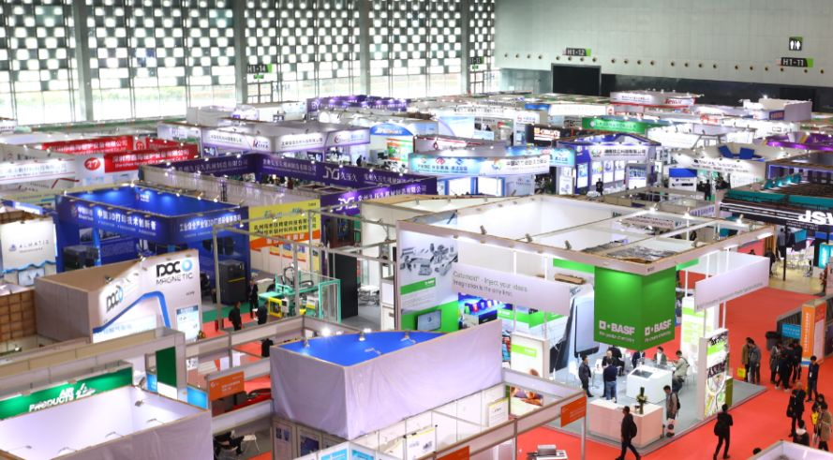
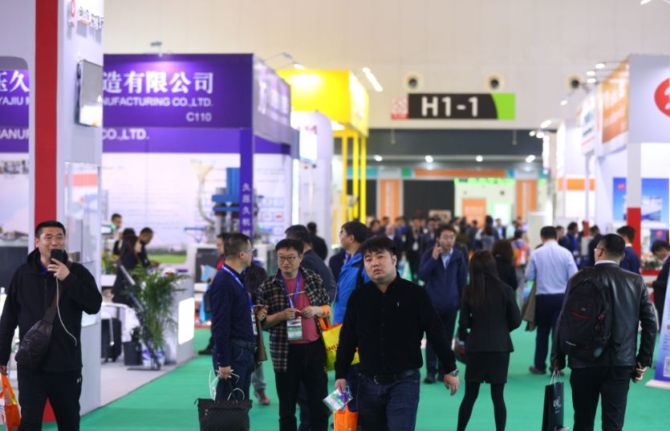

The total exhibition area of the exhibition reached 25,000 square meters, an increase of 12% over the previous edition. The number of exhibitor was 464, a rise of 11% compared with the previous edition. There were 22,637 professional buyers from home and abroad, an increase of 19.5% over the previous edition. Moreover, professional visiting delegations were actively organized to participate in the great event, including Delegation of Advanced Ceramics Industry, Study Group of Korean Advanced Ceramics Industry, Delegation of China’s Advanced Ceramics Industrial Alliance, Delegation of Jiangsu Ceramic Society, Ceramics and Refractory Materials Committee..
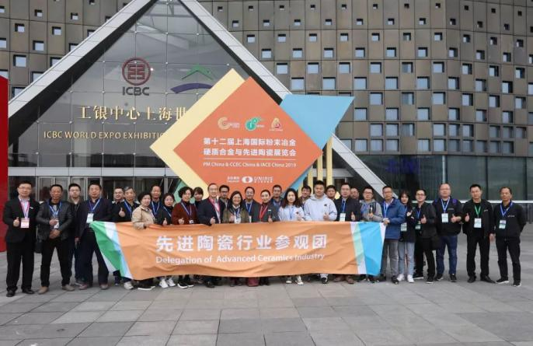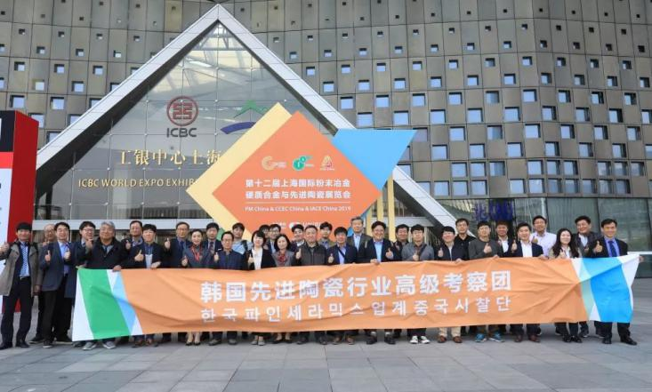
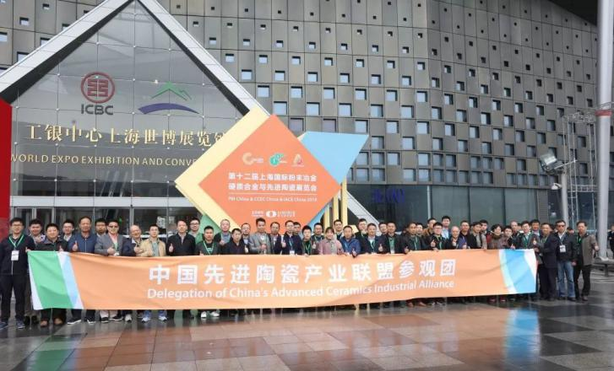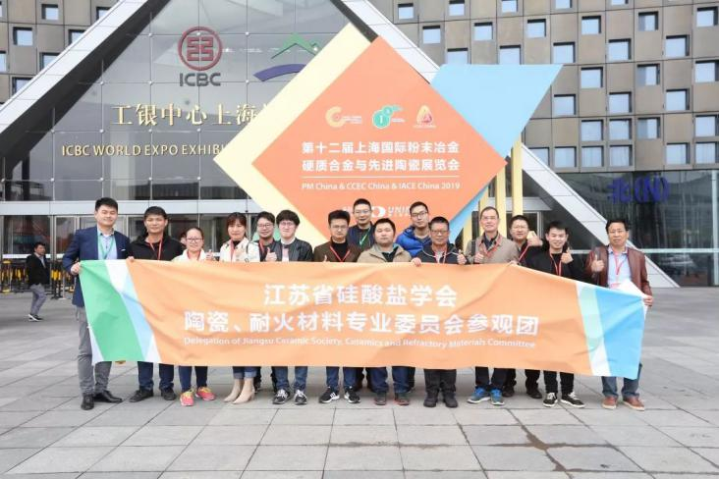

The companies participating in this exhibition are from China, USA, Germany, UK, Italy, France, the Netherlands, Sweden, Switzerland, Austria, Russia, Canada, Japan, South Korea, Poland, Singapore, India, Hong Kong and Taiwan, covering various fields such as powder raw materials, products, mechanical equipment, 3D printing, testing instruments, gas and process solutions. There were about 210 equipment companies, accounting for 45%; about 114 material companies, accounted for 24%; about 120 product companies, accounting for 26%; about 20 3D printing companies, accounting for 5% .

During the exhibition, many high-quality academic forums and exchange meetings were successfully held, including: 2019 China Summit Forum on Cutting-edge Technology Application and Development in Advanced Ceramic Industry & Academic Annual Meeting of the Industrial Ceramics Committee of Chinese Ceramic Society, The 8th Shanghai International Injection Molding Forum, Academic Annual Meeting of China Powder Metallurgy Alliance & 2019 Shanghai International Powder Metallurgy Forum, Launching Ceremony of CHINA ADVANCED CERAMICS INDUSTRY ENCYCLOPEDIA, Establishment Ceremony of China’s Advanced Ceramics Industrial Alliance, Press Conference & Signing Ceremony of Messe Frankfurt and Uniris, China-Korea Advanced Ceramic Industry Exchange Meeting.

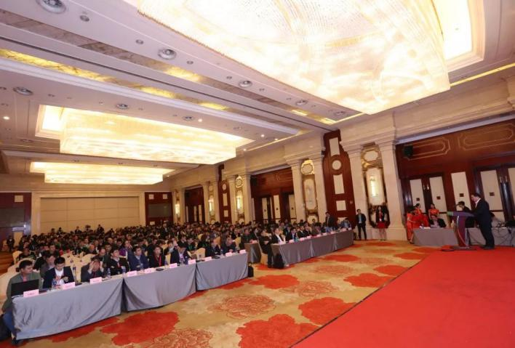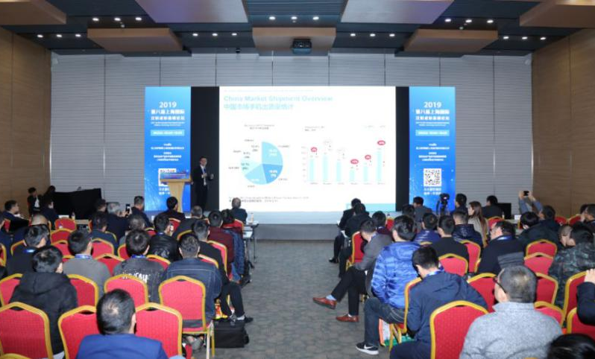
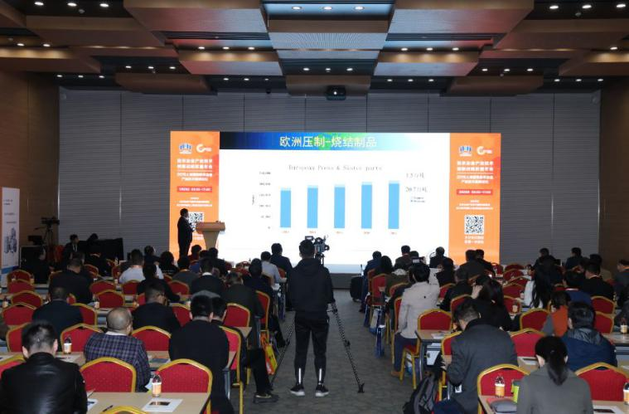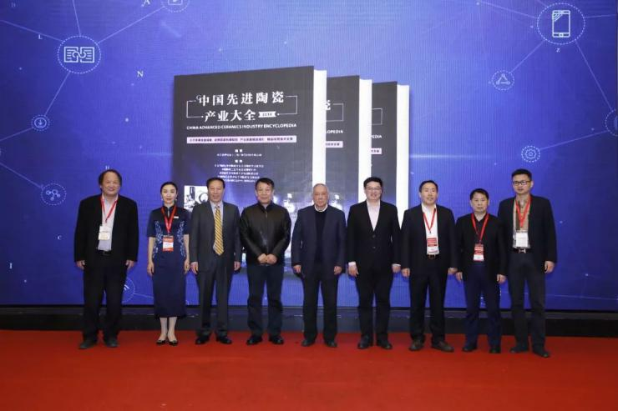
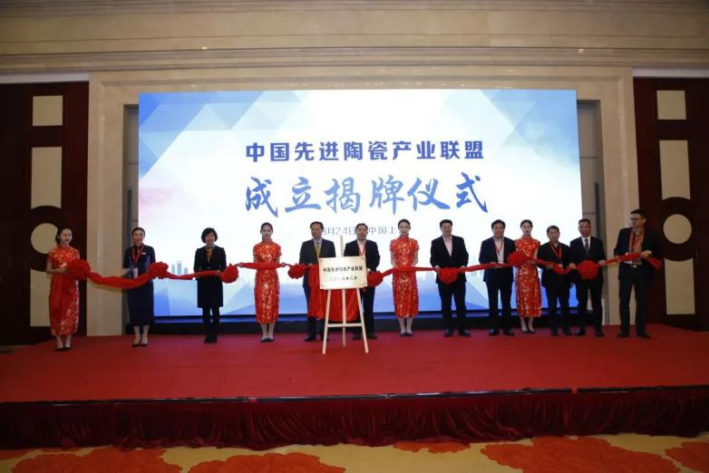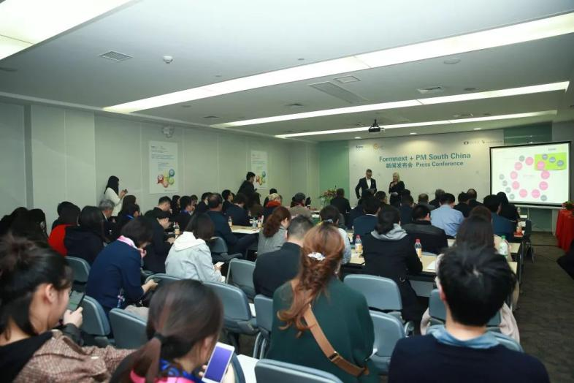
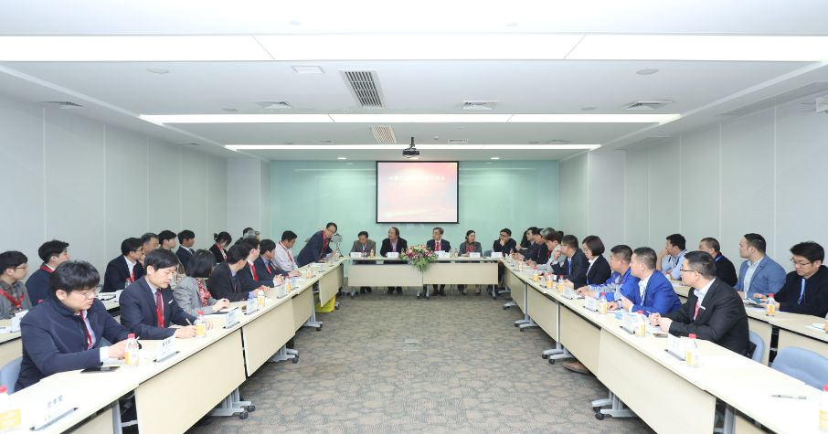

It is worth mentioning that in the press conference and signing ceremony, the cooperation between Formnext and PM China was announced. The two parties will jointly hold the 2020 Shenzhen International Exhibition and Conference on the Next Generation of Manufacturing Technologies and Materials at Shenzhen World Exhibition & Convention Center during September 9th~11th, 2020, aiming to create a bigger cooperation platform for the industries of cutting-edge materials, molding technology and related equipment, and further explore the vast business opportunities in the domestic market. It is expected that the total exhibition area will reach 20,000 square meters, with about 200 outstanding exhibitors from all over the world and more than 10,000 professional visitors. The exhibition will run through a series of advanced materials, technologies, equipment and products in the fields of materials, powder metallurgy, additive manufacturing and post-processing, bringing new business opportunities to the manufacturing industry in China and even in Asia.
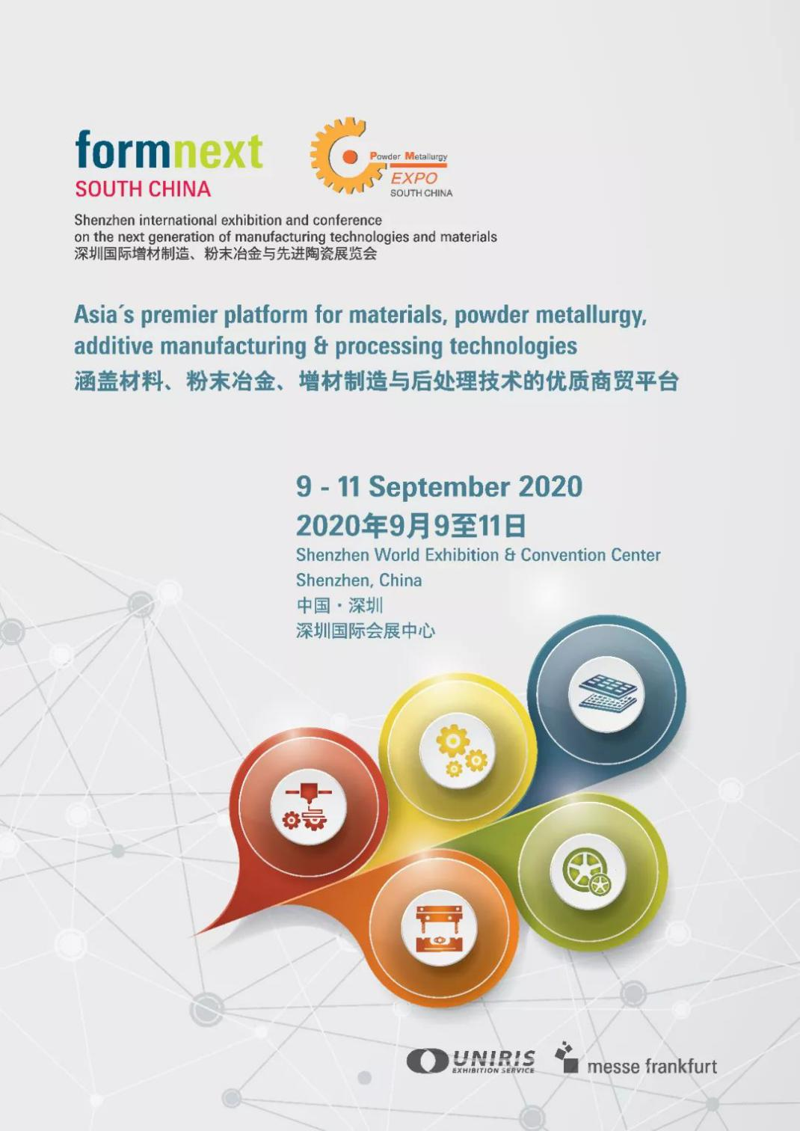

We sincerely thank you for your attention and support to the exhibition. On March 24 ~ 26, 2020, the 13th Shanghai International Exhibition for Powder Metallurgy, Cemented Carbides and Advanced Ceramics will open grandly at Shanghai World Expo & Convention Center, you’re cordially invited to come and join us!
