HDE- One of the Biggest Hotel Shows in Asia

Hotel Plus 2017

As a spin-off show originated from Hotelex Shanghai which takes place every year from Mar-Apr in Shanghai, HOTEL PLUS—Total Solution for Commercial Properties 2017 was successfully held in April 26-29, 2017.

During the 4-day show, Hotel Plus has received 100,000 visitors from all over the world with exhibiting space of 200,000 sqm showcasing products of building, interiors, design, lighting, hotel supplies, cleaning, shops, yachts, etc.

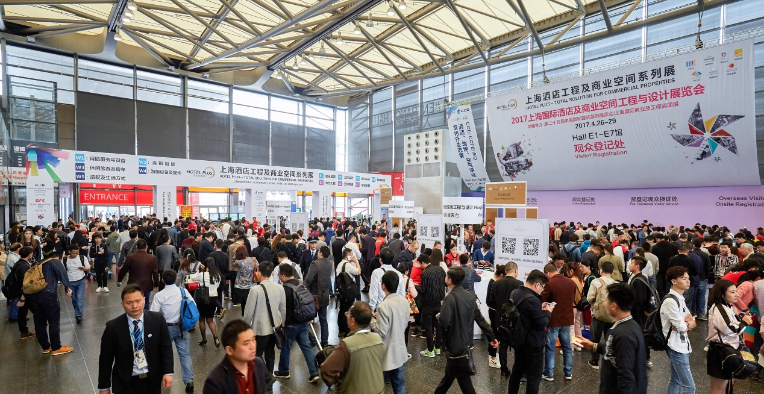
Onsite Registration 2017

As a concurrent event, Design Week Shanghai offered over 40 high level conferences with 200 industry leaders and well known designers sharing their perspectives and experiences on topics like hotel design, sustainable building, lighting design, hotel innovation etc. 21 hotel rooms with various styles have been presented onsite of the show, providing visitors a special hotel tour of technology and artistry.
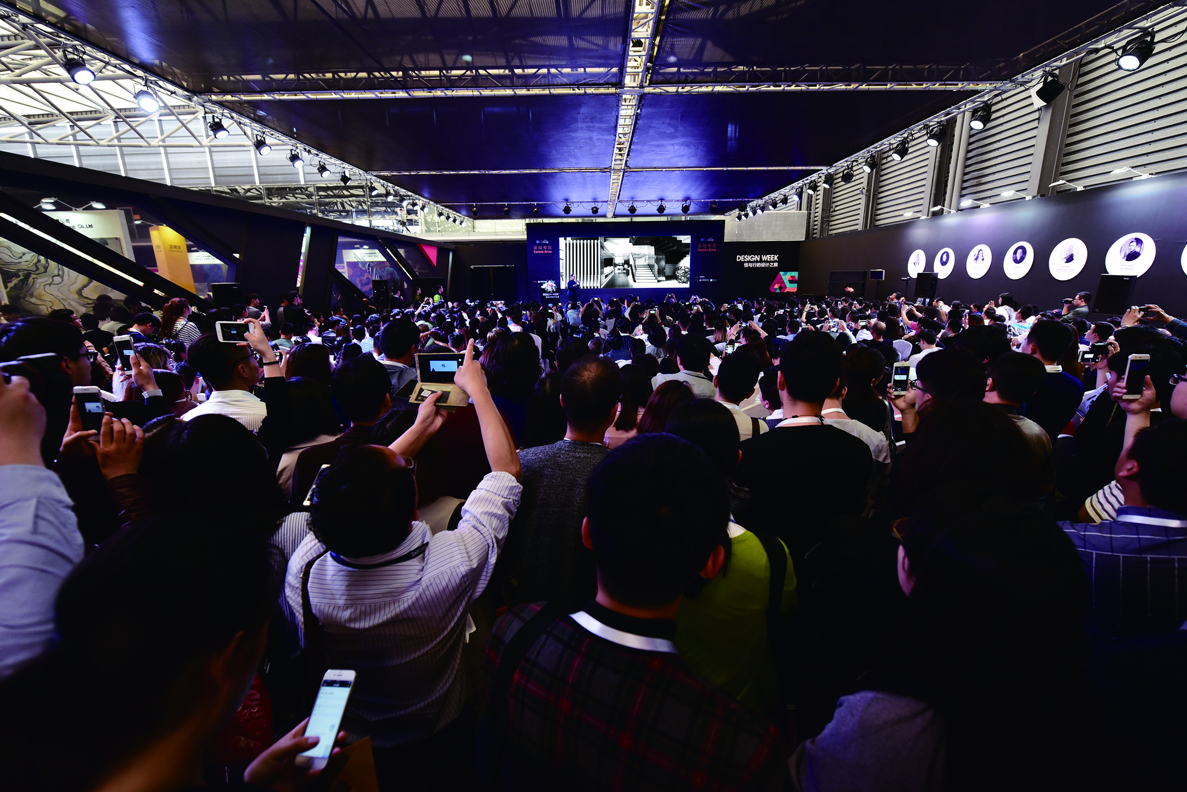
Design Week Shanghai Series Conferences

Shanghai Hospitality Design & Supplies Expo 2018

In 2018, as an important theme show of Hotel Plus event, Shanghai Hospitality Design & Engineering Expo will be renamed as Shanghai Hospitality Design & Supplies Expo due to the move-in of the exhibits of FITNESS & LEISURE, APPLIANCE & AMENITIES, IT & SECURITIES and TEXITILES from Hotelex Shanghai. After the integration, Shanghai Hospitality Design & Supplies Expo 2018 will be the biggest show in hospitality industry in Asia with the exhibition space of 80,000 sqms and can better help developers, designers and hoteliers to find new products, technologies, services and solutions that are related to the hotel and other commercial built environment. For more information about HDE 2018, welcome to visit our website: http://www.hdeexpo.com/en-us/?source=achibazaar
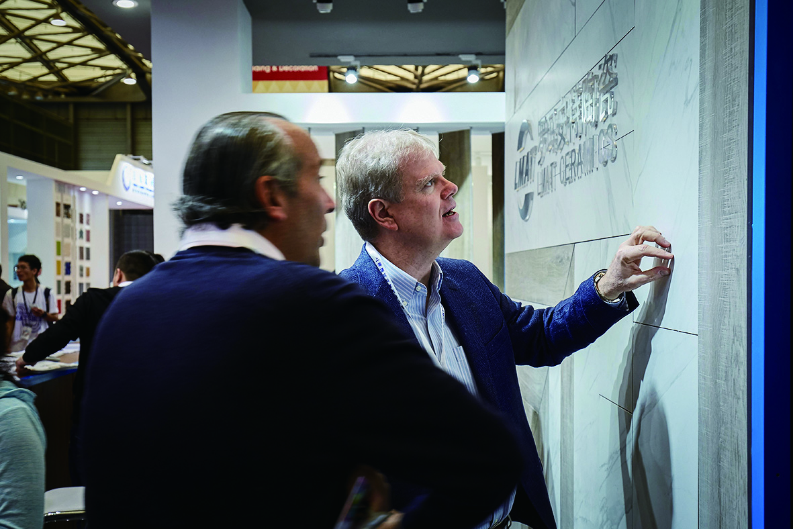
Overseas Buyers

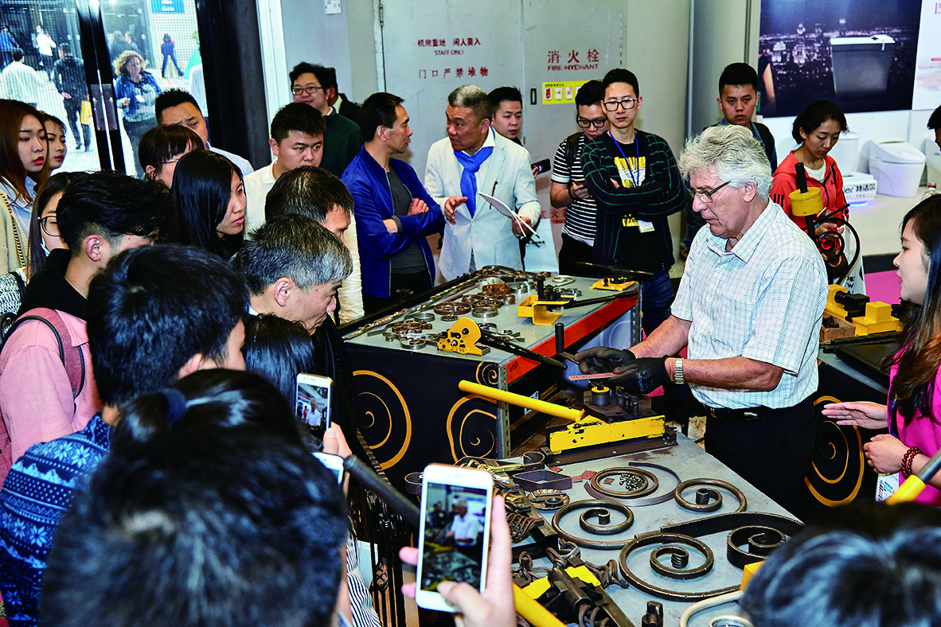
Exhibitor Stand

Concurrent Activities 2018

With more exhibits of hospitality field in 2018, Shanghai Hospitality Design & Supplies Expo will organize more activities onsite to bring participants more exposure opportunities, such as Star Hotel Service Skill Competition, Hotel Uniform Show, Hotelplus Mockup Room Show, etc. The traditional successful design activities will be kept, such as Design Week Shanghai Series Conferences, Real Estate Design China Award, etc.

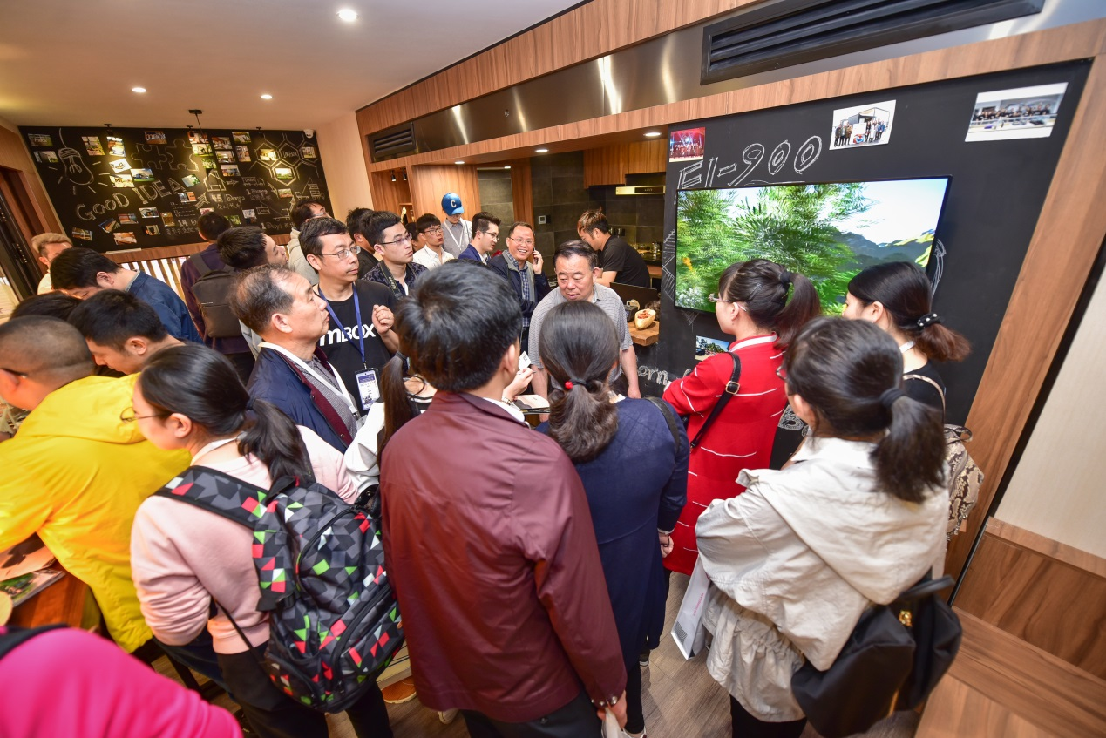
Hotel Plus Mockup Room Crowded with Visitors

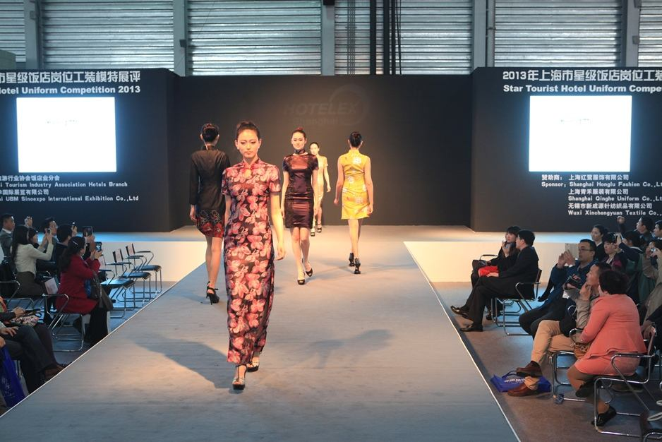
Hotel Uniform Show

Call for Agent and Conference Submissions

In order to promote the show more extensively, the organizer of Shanghai Hospitality Design & Supplies Expo 2018 is seeking for cooperation with more sales agents worldwide. Any companies or organizations have interest to cooperate with us, please feel free to contact: rosie.fan@ubmsinoexpo.com

Senior professionals (designers, hoteliers, architects, etc.) who would like to share their view or experiences in the field of design, building and hospitality management are invited to submit a session topic or presentation for the Design Week Shanghai Series Conferences. Welcome to contact: rosie.fan@ubmsinoexpo.com

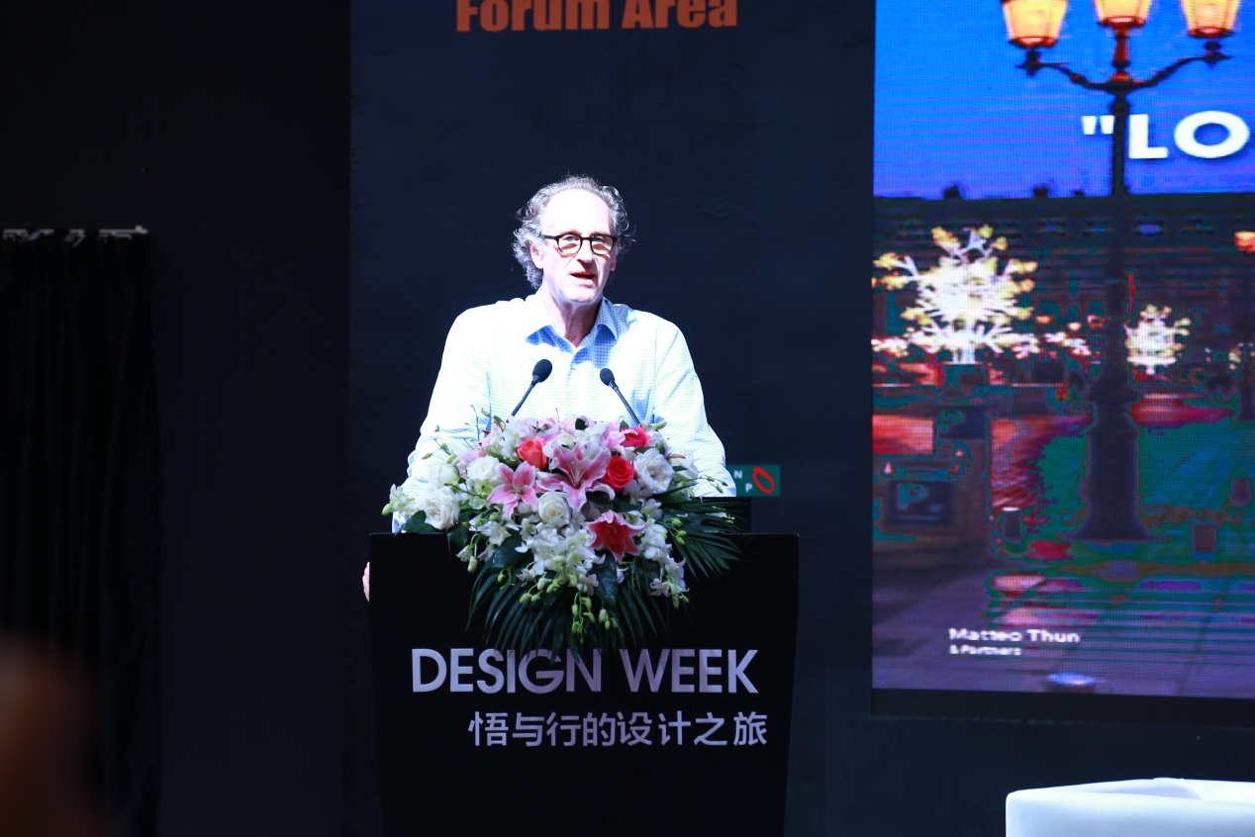
Worldwide Well-known Designer Mr. Matteo Thun is giving a presentation

Want to know more about us? Welcome to visit our website: http://www.hdeexpo.com/en-us/?source=achibazaar or register as a visitor here: https://sinoexpo.ubmonlinereg.com.cn/Registration/default.aspx?fid=751&lang=en&utm_source=tradeindia .

Article from:
HDE Exhibition
Shanghai UBM Sinoexpo International Exhibition Co.,Ltd.

